Daily Tip 14 13/05/2003 11:42:00 PM

Hardware vs. Software fonts in graphs
If you have ever been disappointed by the quality of text in graphs then you may not have made use of hardware fonts. It’s easy to use them and if you’re using windows you can select true-type fonts easily. In the following example I produce PNG format graphs, which are Portable Network Graphics (these have some advantages over some other formats which I will cover another time). Note that when using true-type fonts you should put the font name in quotes, but if you use software fonts then you don’t use the quotes. e.g. goptions ftext=swiss ;
For info on the FTEXT goption see http://v9doc.sas.com/cgi-bin/sasdoc/cgigdoc?file=../graphref.hlp/gopdict-ftext.htm

SAS Program
filename sw 'c:\software font.png' ; * file to save graph using software font ;
filename hw 'c:\hardware font.png' ; * file to save graph using hardware font ;
goptions reset=all gsfname=sw dev=png xmax=6 ymax=4;
proc gchart data=sashelp.class;
vbar sex / sumvar=height ;
run;
* produce second graph using the Arial Font with text height set to 6% of total ;
goptions gsfname=hw ftext='Arial' htext=6pct ;
vbar sex / sumvar=height ;
run;
quit;

Software Font
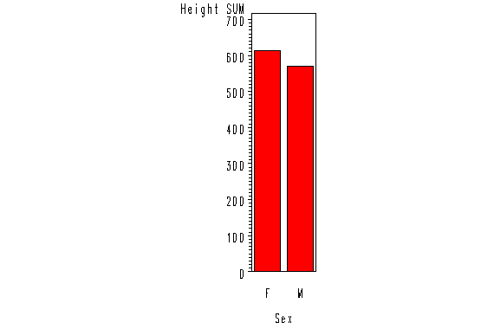

Hardware Font
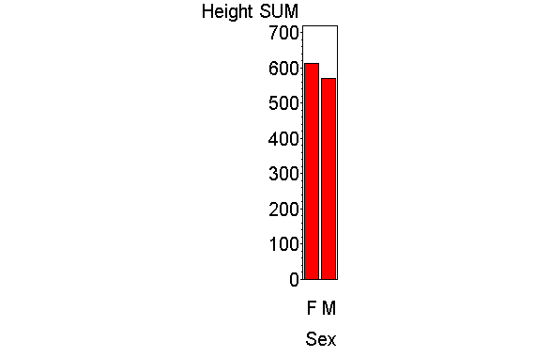
Example tested under SAS 9.0, Windows 2000 by Phil Mason
Wood Street Consultants Ltd. tips@woodstreet.org.uk
www.woodstreet.org.uk

